 Hale School

Semester 1, 2011

Question/Answer Booklet

MATHEMATICS
Circle your teacher’s initials

MRC MAV

SPECIALIST 3CD

Section Two

(Calculator Assumed)

Your name

Time allowed for this section

Reading time before commencing work: 10 minutes
Working time for paper: 100 minutes

Material required/recommended for this section

To be provided by the supervisor
Question/answer booklet for Section Two.
Formula sheet.

To be provided by the candidate
Standard items: pens, pencils, pencil sharpener, highlighters, eraser, ruler.

Special items: drawing instruments, templates, notes on one unfolded sheet of A4 paper, and up to three calculators satisfying the conditions set by the Curriculum Council for this examination

Important note to candidates

No other items may be taken into the examination room. It is your responsibility to ensure that you do not have any unauthorised notes or other items of a non-personal nature in the examination room. If you have any unauthorised material with you, hand it to the supervisor before reading any further.

Structure of this examination

 | Number of questions | Working time (minutes) | Marks available
Section 1  Calculator Free | 7 | 50 | 40
This Section (Section 2)  Calculator Assumed | 13 | 100 | 80
Total marks |  |  | 120

Instructions to candidates

- The rules for the conduct of WACE external examinations are detailed in the booklet WACE Examinations Handbook. Sitting this examination implies that you agree to abide by these rules.

- Answer all the questions in the spaces provided.

- Spare answer pages are provided at the end of this booklet. If you need to use them, indicate in the original answer space where the answer is continued i.e. give the page number.

- Show all working clearly. Your working should be in sufficient detail to allow your answers to be checked readily and for marks to be awarded for reasoning. Incorrect answers given without supporting reasoning cannot be allocated any marks. Any question, or part question, worth more than 2 marks requires valid working or justification to receive full marks. If you repeat an answer to any question, ensure that you cancel the answer you do not wish to have marked.

It is recommended that you do not use pencil except in diagrams.

8. [5 marks]

Consider the triangle OAB with 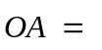3i + 2j +  k and 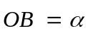i where , which is greater than zero, is chosen so the triangle OAB is isosceles, with 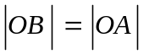

(a) Show that = 4.

[1]

(b) (i) Find 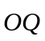, where Q is the midpoint of the line segment AB.

[1]

(ii) Show that is perpendicular to 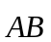.

[3]
9. [7 marks]

A large sporting goods manufacturer specialising in the sale and supply of hockey sticks promotes three major brands: the Harvey, the Aaron and the George. The number of sales varies according to the seasons.

In winter, 90 Harvey, 40 Aaron and 70 George sticks were sold.
In spring, the numbers were respectively 100, 80 and 110.
In summer, the sales were 30, 60 and 120 respectively.

(a) Display this information in a suitable matrix.

[1]

(b) If the takings in winter, spring and summer were $25760, $37910 and $28770 respectively, use a matrix method to calculate the cost of each brand of hockey stick.

[3]

(c) The number of hockey sticks sold is expected to increase by 10% in the following year. The manufacturer also decided to increase the cost of each brand of hockey stick. If the new costs of the Harvey, Aaron and George are $130, $150 and $175 respectively, carry out a suitable matrix operation to calculate the expected revenue for the following year.

[3]
10. [7 marks]

(a) Determine  in terms of x if 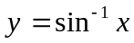 for 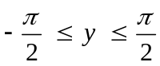.

[4]

(b) Determine the following limit, given that a and h are constants.

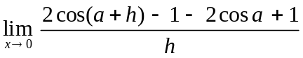

[3]
11. [12 marks]

Let A = 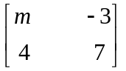, B = 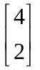, C = 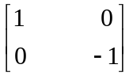 and D = 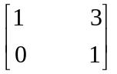

(a) Evaluate each of the following where possible. If not possible, state this clearly and indicate the reason for your decision.

(i) 2A – D

[1]

(ii) BD

[1]

(b) What value(s) of m make the matrix A singular?

[2]
(c) If matrix E is 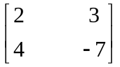 and AC = E, then determine the value of m.

[2]

(d) D represents a transformation matrix. Describe the transformation represented by matrix D.

[1]

(e) If an object is transformed by matrix D followed by matrix F, this would have the same effect as if it were transformed by the matrix 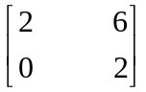. Describe the effect of transformation matrix F.

[3]

(f) Describe the transformations which would ‘undo’ the effect of transformation matrix C followed by transformation matrix D.

[2]
12. [5 marks]

Use the method of proof by contradiction to show that the sum of an irrational number and a rational number is irrational.
13. [6 marks]

The point P on the Argand diagram represents the complex number z. The points Q and R represent points wz and 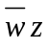 respectively, where 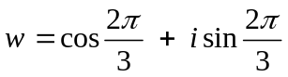.
The point M is the midpoint of QR.
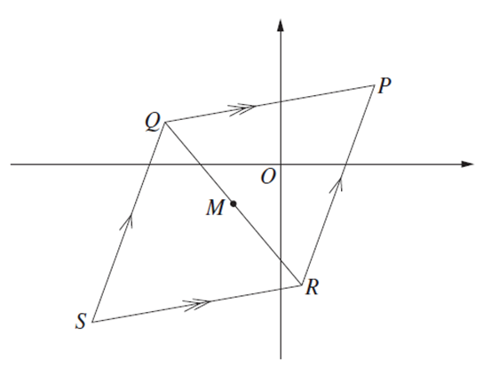
(a) Find the complex number representing M in terms of z.

[3]

(b) The point S is chosen so that PQSR is a parallelogram. Find the complex number represented by S, in terms of z.

[3]
14. [6 marks]

Determine the equation of the tangent to the curve defined by 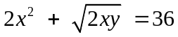
at the point P whose coordinates are (4, 2).
15. [3 marks]

Sketch the region in the complex plane provided where the inequalities
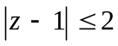 and 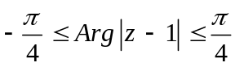 hold simultaneously.

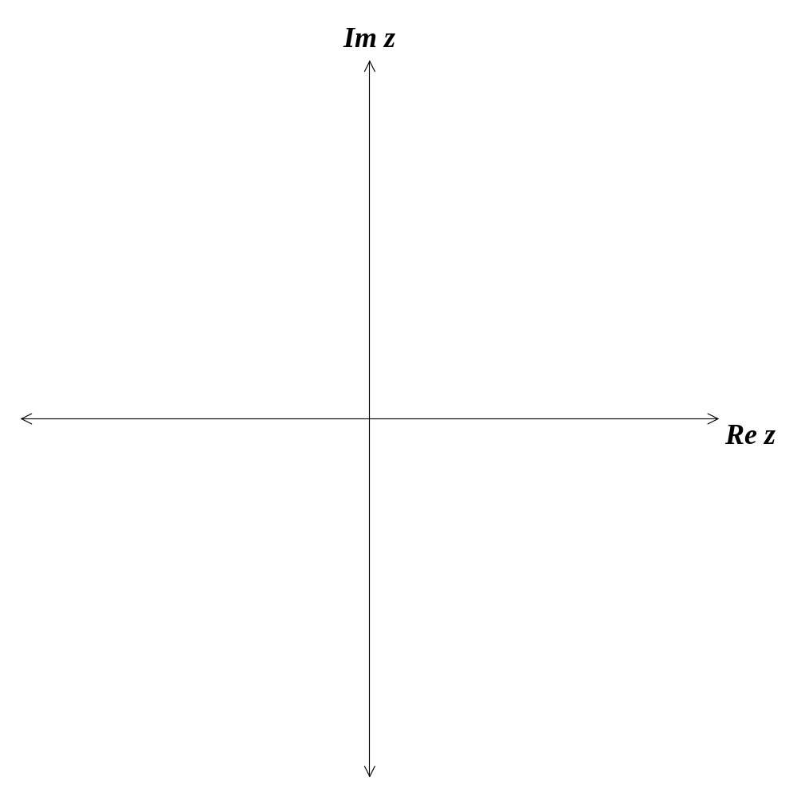

16. [10 marks]

A defensive missile battery launches a ground-to-air missile A to intercept an incoming enemy missile B. At the moment of A’s launch, the position vectors of A and B (in metres), relative to the defensive command headquarters, are 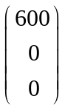 and 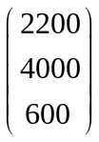 respectively. The velocities (in metres per second) maintained by both A and B are 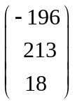 and 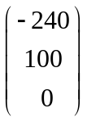.

(a) Show that the ground-to-air missile does not intercept the enemy missile, and calculate ‘how much it misses by’.

[6]
(b) Suppose instead that the computer on missile A detects that it is off target and, 20 seconds into the flight, A changes its velocity and intercepts B after a further 15 seconds. Determine the constant velocity that A must maintain during this final 15 seconds for the interception to occur.

[4]
17. [6 marks]

An aircraft is flying horizontally at a constant height of 1200 metres above a fixed observation point P. At a certain instant, the angle of elevation is 30º and decreasing, and the speed of the aircraft is 480 km/hr.

(a) Draw a diagram to illustrate this information.

[1]

(b) How fast is decreasing at this instant, in radians per second?

[5]
18. [3 marks]

Determine the vector equation of a plane which contains the point A with position vector 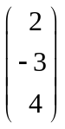 and parallel to the vectors 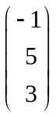 and 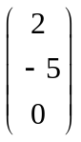.

19. [5 marks]

The female population of a species is shown in the table below together with estimates of breeding and survival rates.

Age (years) | 0 – 2 | 2 – 4 | 4 – 6 | 6 – 8 | 8 – 10
Initial Population | 1800 | 1500 | 1150 | 700 | 400
Breeding Rate | 0 | 0.4 | 1.5 | 1.2 | 0.3
Survival Rate | 0.6 | 0.9 | 0.7 | 0.5 | 0

(a) If no harvesting takes place, estimate the long-term population growth rate.

[3]

(b) What percentage of the population will need to be culled in order for the long term population to be stable?

[2]
20. [5 marks]

Consider the parallelogram shown below. Let 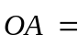 a and 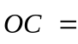 c.

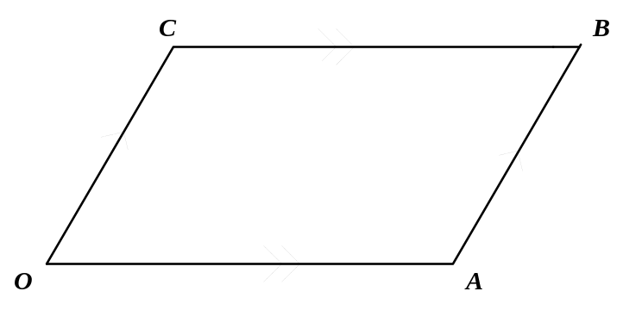

Use vectors to prove that if the diagonals of a parallelogram are perpendicular then the parallelogram is a rhombus.

SPARE PAGE FOR WORKING
SPARE PAGE FOR WORKING

